Development of Human in the loop Agentic Ai using RAG system for intelligent Resume Builder and Optimizer.
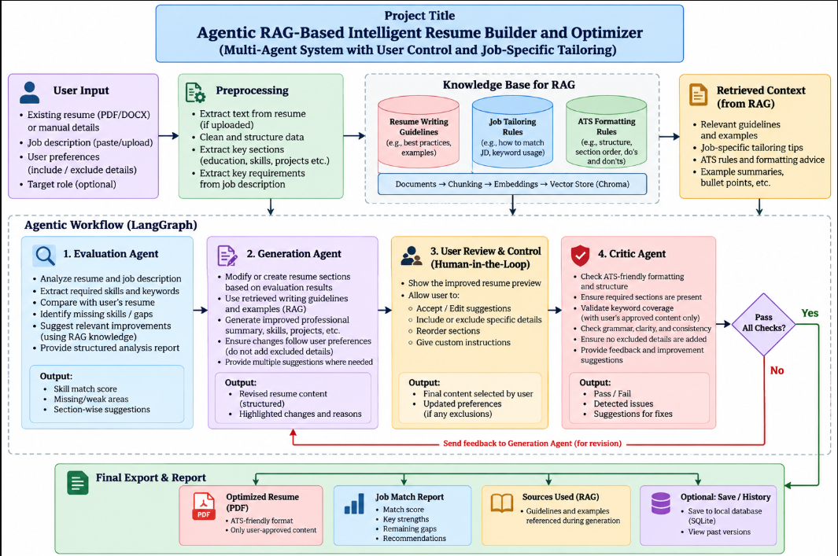
Flowchart:


